|  |  |
| --- | --- |
| Nama | : Afina Putri Dayanti |
| NIM | : 825200049 |
| Jurusan | : Sistem Informasi |
| Mata Kuliah | : Database Design and Management (Teori) |

The EasyDrive School of Motoring case study - Appendix B.2.

15.18 Create a conceptual data model for the case study. State any assumptions necessary to support your design. Check that the conceptual data model supports the required transactions.

**1.1 Identify entity types**

|  |  |  |  |
| --- | --- | --- | --- |
| Entity | Deskripsi | Alias | Kejadian/Kemunculan |
| Staff | Penjelasan tentang karyawan yang bekerja di EazyDrive dapat terdiri dari  Manager, Instruktur, dan Administrasi | Instructor | Setiap anggota karyawan bekerja di satu kantor cabang. |
| Office | Penjelasan mengenai kantor pemberi layanan sekolah mengemudi | School | Kantor memiliki banyak karyawan, banyak mobil untuk belajar mengemudi, karyawan dan satu manajer, dan memiliki  client. |
| Client | Penjelasan mengenai client yang mendaftar untuk belajar mengemudi | - | Kantor memiliki banyak client yang mendaftar untuk belajar mengudi. Client mengikuti wawancara untuk mendaftar. Client bebas memilih instruktur dan  mengganti instruktur pada jawal lain. |
| Cars | Penjelasan tentang kendaraan yang digunakan untuk belajar mengemudi | - | Instruktur dialokasikan untuk mobil ini. Instruktur bebas menggunakan untuk penggunaan pribadi. Mobil selalu diperiksa karyawan secara berkala untuk  perawatan. |

**1.2 Identify relationship types**

|  |  |  |  |  |
| --- | --- | --- | --- | --- |
| Entity | Multiplicity | Relationship | Multiplicity | Entity |
| Staff | 1..*  1..1  1..1  1..* | Work Manage  Interview Inspection | 1..1  0..1  0..*  0..* | Office Office  Client Cars |
| Office | 1..1  1..1 | Have  Register | 1..*  1..* | Cars  Client |
| Cars | 1..1 | Allocated - Lesson | 1..* | Staff |
| Client | 1..1 | Booking – Lesson | 1..* | Staff |
|  | 1..1 | Ask for – Lesson | 1..* | Staff |
|  | 1..* | TestDrive | 1..* | Cars |

**1.3 Identify and associate attributes with entity or relationship types**

Attributes for entity:

|  |  |
| --- | --- |
| Staff | staffNo, compite(fName, lName), Address, Job, salary, sex, dob |
| Office | officeNo, composite(Address, Postcode), TelNo |
| Cars | carsNo, brand, model, color, capacity |
| Client | clientNo, composite(fName, lName), composite(Address, Postcode), TelNo, |
|  | sex, dob, licence |

### Attributes for relationship (entity relationship):

Interview iDate, iTime, iRoom, iComments

Inspection inspectDate, faultsNote, comments

Lesson type, date, time, progress, mileage

TestDrive testDate, testTime, testCentre, result, testComments

|  |  |  |  |  |  |  |
| --- | --- | --- | --- | --- | --- | --- |
| Entity | Attributes | Deskripsi | Type & Width | Nulls | Multi  values | Composite |
| Staff | staffNo, fName, lname,  Address (street, district, province), Job,  salary, sex, dob | Primary key, mengidentifikasi setiap staff Nama depan staff  Nama belakang staff Alamat staff  Jabatan Staff Upah staff  Jenis kelamin staff Tanggal lahir staff | Char (6)  Varchar (30)  Varchar (30)  Varchar (90)  Varchar (20)  Char (9)  Char (1) Date | No No No No  Yes No Yes Yes | No No No No  No No No No | No No No Yes  No No No No |
| …. | ….. | ….. | …. | … | … | … |
| Lesson | type, date, time, progress,  mileage | Tipe pelajaran yg dipilih client  Tanggal pelaksanaan pelajaran mengemudi Jam pelaksanaan pelajaran mengemudi Perkembangan kemampuan mengemudi  Jarak tempuh selama mengemudi | Char (1) Date Time Text  Char (3) | No No No No  No | No No No No  No | No No No No  No |

**1.4 Determine attribute domains**

|  |  |  |  |
| --- | --- | --- | --- |
| Entity | Attributes | ……….. | Domain |
| Staff | staffNo, fName, lname,  Address (street, district, province), Job,  salary, sex,  dob | ……….. | ………..  ………..  ………..  ………..  Manager, Instructor, Administration, Technician 20 – 100 dollar  M or F  ……….. |
| …. | ….. | ……….. | … |

**1.5 Determine candidate, primary, and alternate key attributes**



1..1

manage

0..*

1..*

1..1

1..1

inspection

0..*

1..1

interview

askforby

Register

1..*

0..*

1..*

allocated

lesson

booking

1..*

1..*

1..*

0..*

1..*

testdrive

testTime, testCentre, result, testComments

carsNo {PK} brand model

color capacity

clientNo {PK} fName lName Address Postcode TelNo

sex dob licence

Client

Cars

iDate iTime iRoom iComment

inspectDate faultsNote comments

officeNo {PK} Address Postcode TelNo

staffNo {PK} fName lName Address Job

salary sex dob

work

0..1

1..1

Office

Staff

type date time progress mileage

 have

### Attributes dengan primary key:

Staff **staffNo**, fName, lName, Address, Job, salary, sex, dob Office **officeNo**, Address, Postcode, TelNo

Cars **carsNo**, brand, model, color, capacity

Client **clientNo**, fName, lName, Address, Postcode, TelNo, sex, dob, licence

**1.6 Consider use of enhanced modeling concepts (optional step)**

### Tidak diperlukan

**1.7 Check model for redundancy**

Tidak ada kerangkapan relationship

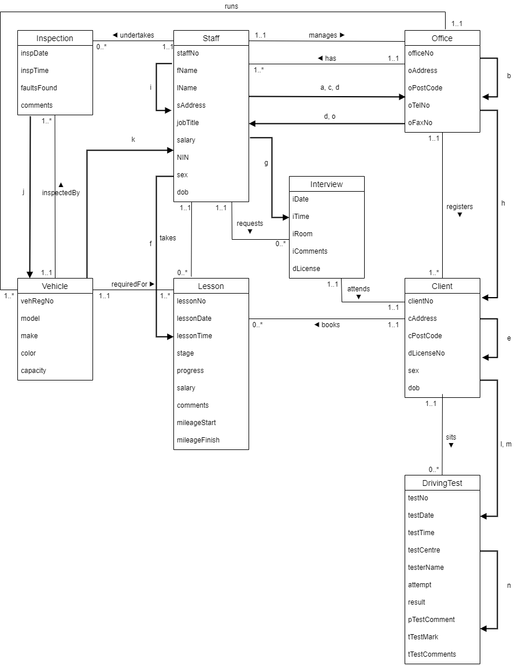**1.8 Validate conceptual model against user transactions**